PRACTICAL ASSIGNMENTS LAB1 & LAB2 & LAB3

DYNAMIC FEEDBACK CONTROL DDC4

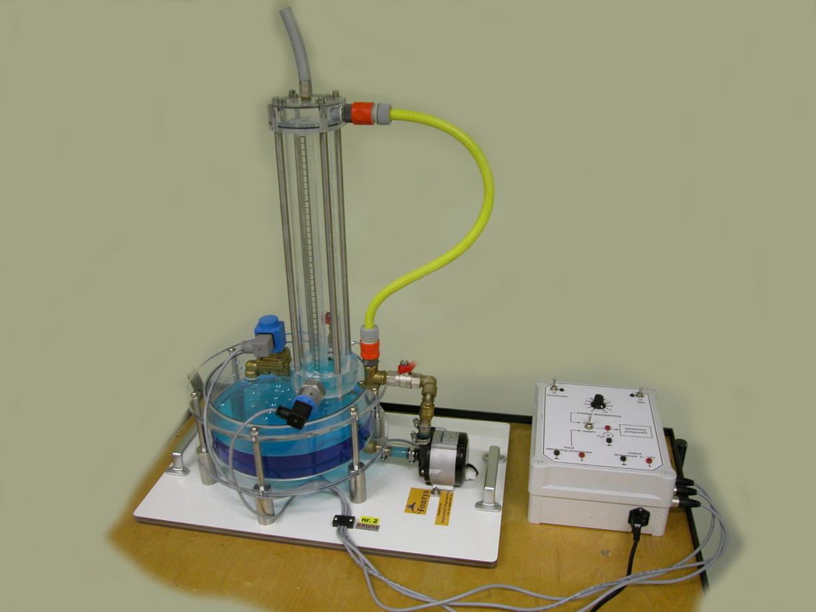

Albert Aslan

VERSION 2022

pre-Lab pREPARATIONS AND REQUIRED SOFTWARE INSTALLATION

To perform this practical you need to

1) Install and activate Matlab/Simulink version 2019b or higher

2) Install the Matlab add-on **Data Acquisition Toolbox**

-Click on HOME tab -> Add-Ons

-Search for “**Data Acquisition Toolbox”**

**-**Log in with your student.fontys.nl account that you have created in Mathworks to activate Matlab.

## 3) Do the same steps as 2) again to install the Matlab add-on Data Acquisition Toolbox Support Package for National Instruments NI-DAQmx Devices.

4) Bring your myDAQ and the USB connection cable to the practical class and of course your computer.

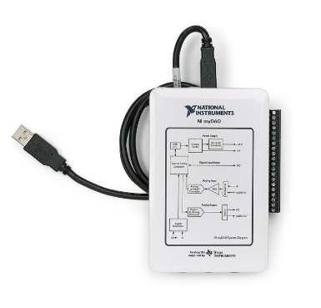

In-Lab EXERCISES

STARTING UP THE FIRST MEASUREMENT EXPERIMENT:

1) Get two black and two red cables from the open drawers.

2) Each group borrows a green interface board to connect to your myDAQ from the practical teacher. You must return the green interface boards at the end of each practical class because we don’t have many.

3) Connect the cables to the green interface board as shown in the picture above and connect your myDAQ to your laptop with myDAQ’s USB cable you brought.

4) Connect the other ends of the cables to the water tower control box as shown below.

*Attention*: The output of the water tower control box (i.e. output druksensor (pressure sensor) +) is the input to the green interface board (i.e. AI0+);and similarly, the input of the water tower control box is the output to the green interface board.

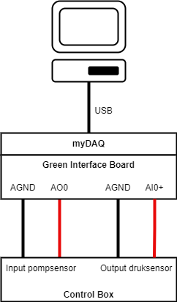

5) Plug in the water tower control box to the electricity and don’t forget to switch it on from the back.

6) Turn on the switches called pompmotor (pump motor) and klep (valve) to “aan”. The valve must stay on the whole time.

7) Bring the middle switch to “intern” and turn the knob to 2/10. You should now see water level increasing in the tower.

8) Write down the setup number and use the same setup each lab. Each water tower behaves differently.

9) Download the file “DFC4PIDLab2019b.slx” from canvas and launch it with Simulink.

10) Run the file and you should now see the actual water level in the scope called “Water level measurement in Voltage”.

**LAB1 ASSIGNMENT:**

Goal: Get started and determine a first order approximated model experimentally for the dynamic behavior (input-output relation) of the water tower. Build the model in Simulink using the blocks: Transfer Function, Gain, Offset, and Saturation. Make sure you gathered and saved a copy of all the experimental data you need before the class ends.

The water tower system has a voltage input (pump motor) and voltage output (pressure sensor to represent the water level. This behaviour can be represented by the differential equation. An example to such a first order differential equation is the following $τ\frac{dy(t)}{dt}+y\left(t\right)=x(t)$ where $x(t)$ is the input and $y(t)$ is the output and the differential equation represents a linear system. A system has static and dynamic behavior. One can call the static behavior as the steady state behavior and the dynamic behavior as the transient behavior.

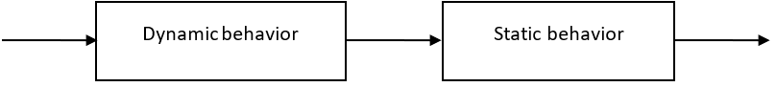

*Start with the static behavior:*

Static behavior is the reaction of the system when waited for very long time. For example, you give 2V input and after 2 minutes the output converges to 3V. This is an amplification of 1.5. You give 0.5V input and after 2 minutes the output is still at 0. This is recognized as the dead zone. Eventually the controller should work for the operating region (outside of the dead zone).

Try a bunch of input voltages (either internally by turning the knob for input voltage or externally through Simulink step functions) to make a steady state input-output relation graph using data you gathered from the experiments.

*Dynamic behavior:*

In the *water tower* (regulation of a level) we touch on a process that can globally be seen as a *first order system*, in which the time constant is determinative for the speed of the process.

In both cases we realize the dynamic part of the scheme with a *Transfer* function. For example

$$\frac{1}{1+0.2s}$$

When you combine the static behaviour with the dynamic behaviour with saturation block on the measurement side you should end up with a model that looks like:

**The aim is to make such a Simulink implementation to simulate the water tower system.**

Make sure to have correctly worked out your measurements *and* obtained the process parameters below:

* The process amplification Kp = ……
* The time constant τ = …… seconds
* The offset on the process line (see the steady state input output graph) ……V
* The maximal and minimal values of the output (process limits): min = ……V, max =……V
* The linear work area of the process (not needed for Simulink interpretation): from …… V to ……V

Filling in the table above experimentally can be challenging due to a slightly different reaction of the system in each of the zones. That’s why it is recommended to go in steps of 2V (0V->2V, 2V->4V, 4V->6V, 6V->8V, 8V->10V) upwards and then downwards (10V->8V, 8V->6V, 6V->4V, 4V->2V, 2V->0V) as shown below.

For each of the 5 upwards and 5 downwards step responses you might get a different amplifications and time constants (thus in total 10 different amplifications and time constants). In fact, you only need 1 good representative amplification and time constant. A good method would be averaging up those amplifications and time constants but first make sure that the numbers that lie far away are not taken into the averaging. Because you find one transfer function that is valid for the response inside the operation region.

Don’t forget to save your experiment data to your cloud, send an e-mail to yourself or use a USB stick.

save("data.mat") saves your workspace variables in a .mat file.

**LAB2 ASSIGNMENT:**

Goal: Verify and simulate your found model in Simulink. This model should represent the experimental results. After the verification, simulate a controller in Simulink that makes the water level follow a step signal reference to 5V.

1) If necessary, gather additional experimental data to complete your model.

2) Put experimental graphs on top of the simulated graphs to show the (mis)match. This might require some time to send all the data to Matlab Workspace and manipulating the data in such a way that the curves are next to each other visually.

3) To make your model represent the reality better, add some noise at the output and use saturation blocks where necessary because the actuation and measurement has limits.

4) Verify your model with the practical teacher.

5) Make a simulation of the P-controlled process. Comment on how realistic the simulation is with respect to the reality. Make sure your simulation graphs contain the reference, process output and the regulator output as shown below.

**LAB3 ASSIGNMENT:**

Goal: Test the P-controller you simulated on the experimental setup. Then build, PI, PD, and PID controllers and tune them for the best result.

In the scope called “Actuation of the Pump Motor in Voltage” you can see the control input that goes to the pump motor. On the left of the saturation, you should implement

1) the error calculation e=r-y

2) PID controller for the actuation

$u(t)=K_{i}\int{e\left(t\right)dt}+K_{d}\frac{de(t)}{dt}+K_{p}e(t)$

Note: Do not use the readily available PID block in Simulink. Build it manually using the 3 parallel branches. As the formula suggests one branch should contain the derivative and one branch should contain the integrator.

<- Turn the middle switch to “extern” such that the control box accepts the control input signal from the Simulink file and not from the rotary knob.

1) To what extent does the closed loop performance in simulation match the closed loop performance in experiments?

2) Build and experiment with PI, PD, and PID controllers. What are the roles of P, I and D controllers in this system? What are the best values you tuned for $K_{p}, K_{i},$ and $K_{d}$? How do the experiment results compare to simulated results?

3) Write down the experimental performance summary of the closed loop system. In other words, what are the achieved settling-time, rise-time, overshoot, steady state error, peak time?

**Handing in:**

Hand in this assignment together with all other practical assignments of DFC4, **7 days 0 hours** after the last official practical session. If your final report is unsatisfactory, a one-time repair chance (resit) will be offered the next quartile given that enough effort and attendance has been shown. There won’t be any supervision during the repair period by the practical teachers.

Hand in your assignments via e-mail to your practical teacher.

Name your report:

* *yymmdd*_dfc4p*Class*Group# _f*irstNameLastName1FirstNameLastName2.pdf*

In which you fill in “yymmdd”, “Class”, Group#, *firstNameLastName1* and *firstNameLastName2* in yourself. I.e.: If my name would be David Reuijl and my colleague’s name would be Albert Aslan and we are group 7 and the date is 13/11/22 and we are in M2A, we would hand in a document called: **221113dfc4pM2aGroup7AlbertAslanDavidReuijl.pdf.**

Make sure to also place your name, student number, group number and class on the first page of your report.

Note that the format should be PDF.

If you do not meet these requirements, we will refrain from checking your work.

**Practical Rules:**

**NL:**

* Frauderegeling: Groepen mogen onderling samenwerken maar verslag moet per groep geschreven worden zonder enige copy-paste van de andere groep(en). De groepsgrootte wordt bepaald door de vakdocent tijdens het practicum. De verslagen die veel op elkaar lijken worden beschouwd als fraudegevallen.
* Aanwezigheid: is verplicht voor de practica met opstellingen.

**EN:**

* Plagiarism regulation: The groups can brainstorm and work together but the reports must be written per group separately without any copy-paste from the other groups. The group size will be determined by the practical teacher. The reports that look similar to each other are considered as plagiarism and any suspicions about that will be forwarded immediately to the examination board for further check.
* Attendance: is mandatory for the practicals with setups.